Carroll Mizelle: A True Viking
Avery Bales
North Mecklenburg High School is located on the edge of Huntersville, North Carolina. About twenty minutes north of Charlotte, the town stands tall, welcoming all to the so-called “small town.”
In the 1950s, it was a quaint town with the charm of a community atmosphere and no traffic.
That ended in 2000. By 2023, the town's population had tripled, and it now had 63,000 residents. Not so small, right?
One man watched the town grow like the tomatoes and flowers in his garden. He watched North Meck High Schools population rise like his best player used to dunk. He watched his church surge in members, just like the surge he experienced in his marriage.
While everything changed around him, the man stayed constant. Never missed a beat. Never missed a game. Never missed a birthday. Never forgot anything. He never stopped, always doing whatever he could, even at seventy-eight.
That was until he was diagnosed with melanoma.
**********

Francis Carroll Mizelle Jr. Carroll Mizelle. Coach Mizelle. Mr. Mizelle.
Born in 1946, he grew up in the same town. He stayed in the same house on Highway 73, never selling or moving, no matter how much money he was offered.
Consistency, Support, Love, and Passion.
Those are just a few of many words to describe Carroll.
His story begins at North Mecklenburg High School, where he graduated in 1965.
Not wanting to go far away, he stayed in Charlotte and attended the University of North Carolina at Charlotte.
He has always loved science and physics, so he got his degree in physics. He then spent an extra year earning his master's in education. He didn’t know teaching would be his path, but he was naturally called back to North Mecklenburg High School.
He wanted to be a Viking forever.
*********

Sadly, the physics position was filled, so he chose math. After all, his family had German origins, and according to one of Mizelle’s jokes, “All Germans are Mathematicians.”
This wasn’t his only skit in his classroom. He’d invite other math teachers down the hall to help him with a true mission: slaying the dragon.
Mr. Mizelle would go into the textbook closet which he called the dungeon. Apparently, an imaginary dragon lived there, and he would have to fight it every time he went in.
Ken Kennedy taught in the classroom next to him and experienced the fun. “He’d come into my room and slam the door, and go, ‘time to slay the dragon! Grab the yardstick,” said Kennedy.
Never boring, never dull, always using humor. Carroll’s personality traits always went into Mr. Mizelle’s teaching style.
Another one of his favorites: “The train is coming! Get down!”
Mr. Mizelle’s classroom trailer was right next to the train tracks. When the train arrived, the students knew to get under the desks and prepare for the rumble.
“Even a year later, always texting me, 'hey, careful, the train's coming,” Kennedy said.
Little moments like these were the reason Mr. Mizelle loved teaching. Everyone wanted to learn from him, and everyone respected his balance between learning and fun.
A principal during Mr. Mizelle’s teaching career, Jimmy Poole, said, “When I would drop in on classes almost every day, you know, for just a minute or two, just to kind of see what's going on. One of the things he used to say when I'd come in was, ‘Do you want to work the next problem?’ I'd say, I don't think so. I think they need me in the office. I've got to go. It's time for me to leave.”
Robert Bales, a 1985 North Meck Graduate, said, “I always heard the tales of what went on in Mr. Mizelle’s trailer, and I wish I would have been able to learn from him.”
His impact as Mr. Mizelle was widespread, and he was truly the talk of the school.
Even those who didn’t have him as a teacher always saw him standing outside his trailer, greeting students as they passed.
He offered all kinds of support, math help, and jokes for those who struggled. He had a special way of explaining even the most complicated math functions.
At the end of the school day, once the bell rang, he wasn’t Mr. Mizelle anymore: he was Coach Mizelle.
********
Coach Mizelle began with the JV boys' basketball team, working alongside Leroy Holden, the varsity head coach.
After the coach resigned, Mizelle took the position in the same gym he would etch his legacy
The girls' basketball team had been dormant since 1958. There was little interest in the team, causing its fallout. Once women’s basketball started rising in 1975, they reemerged the next year having a team of ten girls.
Once Mizelle was the head coach, the first few seasons were successful. Coach Mizelle began his emphasis on working together, and led the 1980 team that placed first with a 15-2 conference record. They had an overall 17-2 record and earned sixth place in the state.
The following season, the team ended with a 14-4 record, continuing the success in the conference under Coach Mizelle.
One thing Coach Mizelle always did was play all the girls on the roster. Even with star players, everyone got their fair share of playing time.
In 1985, his team won the conference. In the Charlotte Observer, Coach Mizelle said, “Others think only about the regular-season title. We try to play as well as we can every game.”
Coach Mizelle preached teamwork and collaboration. The best player he coached, Andrea Stinson, said, “We were a team, we played together, and he was a big part of that because he explained to us that this wasn't gonna work if we didn't play together.”
The same year his team won the conference, Coach Mizelle was named Coach of the Year by the Charlotte Observer.
Coach Mizelle led gracefully and let the girls play as hard as possible.
Mizelle’s daughter, Heather said, “He was mostly fairly calm. He would tell you he didn't yell at the referees, but he did. He'd say, Ohh, no, I never yell at the referees, but he did. I think they just, after he had been coaching for a while, they just kind of respected him enough that they just let it happen.”
With years of experience under his belt, referees recognized him and respected him. That viewpoint reflects what everyone thought of him.
His players respected him; other coaches respected him.
The year that followed redefined what success looked like under his leadership.
Andrea Stinson was a key leader of the 1986 season. But before she paved her career, she started under Coach Mizelle in the North Meck gymnasium.
The season started with the Lady Vikings on fire, reigning undefeated. In January, they faced a test against Gastonia.
The team entered the game 9-0 on the season and had high hopes for what was ahead.
Coach Mizelle’s team had a strong lead against Gastonia throughout the game until Gastonia came out of halftime playing hard.
With about two minutes left, the game was tied at 51. The last few minutes were up for grabs.
“I felt at the end it could have gone either way,” said Mizelle. “But we had the lead earlier in the game and should have been more confident.”
North Meck took home the win, continuing their undefeated run.
Fast-forward to the state playoffs, and North Meck is set to face South Mecklenburg High School in the first round.
South Meck fought hard to defeat the Vikings, but Stinson made two free throws to win the game.
North Meck stayed undefeated after the first round with a 21-0 record.
Next, the team faced North Forsyth in the semifinals, and they soared, winning the game 77 to 57.
“We knew they would make a run at us, and they made several,” said Mizelle in the Charlotte Observer. “Luckily we made the big plays when we needed them.”
The team now advanced to the championship game to play Pine Forest High School at Elon College.
The game started close. At the end of the first period, it was tied at eleven. Coach Mizelle let the girls play– and reminded them that teamwork was the only way they could win.
The Vikings widened the gap until the last period, when it became 54 to 50. Stinson made crucial free throws yet again to get her team the crown.
It wasn’t just North Mecklenburg girls’ basketball anymore–it was State Champions, the North Mecklenburg girls’ basketball team.
Coach Mizelle was now a state champion.
When asked how they did it, Mizelle said, “Everything has to work perfectly. You’ve got to play well and be lucky.”
That sums up Coach Mizelle. Never taking all the credit. Humble as can be.
“Coach Mizelle was just a great guy; he loved us, the team, and he loved coaching the team,” said Stinson.
“To run a perfect season, that's quite a feat,” said Leroy Holden, the boys' basketball coach. “But he handled it with grace. He didn't make a big deal about it. So, he'll never be forgotten in that team.”
Holden was right. He was never forgotten. Half the team came to his funeral to show up for a coach who had always shown up for them. Stinson even attended and shared her compassion with the family.
“I felt like I was part of his family. You know, you kind of feel that way with him. He doesn't allow you not to feel that way,” said Stinson.
Coach Mizelle preached teamwork, and he was a part of that. After tournaments and games, they would grab food. The team would gather in his classroom for study hall and to watch the film. He would help the team with any homework issues and explain concepts to the best of his ability.
Coach Mizelle was never just the team's head coach. He was also a mentor, a supporter, and a figure to look up to.
“He impacted my coaching, because I use the same philosophy he did, you have to be a team to win,” Stinson said. “And I learned that from him, because I saw it, lived it, and played with it,”
Coach Mizelle continued his career for twenty-seven years. He retired from coaching in 2001, coaching his last season after leading his team to the 4A semifinal and the conference championship.
The fitting part was that he asked Ken Kennedy, a neighboring teacher, to take over for him on a random day before classes started.
“We were outside one day, and he was like, ‘It's my last year coaching. Do you want the job? I put in a good word for you,” Kennedy said.
Typical Coach Mizelle. Simply ask Kennedy before class. Not making a big deal about it.
Kennedy took the job, and Coach Mizelle guided him through the politics of parents and players.
“He gave me advice but never told me what to do,” said Kennedy.
Even after letting go of his coaching career, he sat back and watched. He always supported and was at every game, whether home or away.
Usually, a coach who retires still wants to have some say in what happens with “their” team, but not Coach Mizelle. He trusted Kennedy and gave guidance when asked.
Even though Coach Mizelle retired eight years prior, Mr. Mizelle continued to teach until 2009 when he would retire.
The place he spent 43 years at. As a student, as a teacher, as a coach.
They wouldn't get rid of him that easily, though. He was a Viking forever.
********
No longer Coach Mizelle, Carroll still showed up.
He walked into every game wearing jeans, a North Meck Basketball sweatshirt, and a blue hat.
He was in the stands, a coach turned fan. Football, basketball, baseball—you name it, and he was there. It became the usual: always seeing him there, always supporting.
That's who Carroll was.
Carroll was a gardener, father, and neighbor outside of North Meck.
Described as a family man, he married Judy Callahan in 1969 after meeting her while earning his master's in education at UNCC.
Judy was a secretary for the biology department, and Carroll was an intern in one of the labs. He saw her every time he came by to pick up the key and never said anything until he asked her if she wanted to go to a movie with him.
The rest of their love story unfolded. When Carroll became a teacher, students enjoyed dinners at their house and often spent time with Carroll outside school.
In 1976, they welcomed Heather into the world. Judy went into labor Thursday night before a game. At this time, Carroll was the JV boys’ basketball coach.
“I had been sitting on that bench Tuesday night watching them with my stomach out there. Didn't miss a game, and then they had to go lose, and I had to go have the baby,” said Judy.
A baby wouldn’t stop her from attending every game Carroll coached after Heather was born.
“So we went, she never cried. She sat there and watched the game, or she'd go to sleep. And people said, I've never seen anything like it. I thought, that's all she knows,” said Judy.
Heather wouldn’t change it for the world. She loved to watch the games with Judy and cheer on the Vikings as hard as they could.
“Many hours on those bleachers, games twice a week. I went to Huntersville Elementary, so he would pick me up from school, bring me back, and I would be at practice. Just watching it happen. Then, as I got older, I would help. When she washed the uniforms, I'd play them out and run the clock, water bottles, and all that,” said Heather Mizelle Gibson.
With the family support like Carroll had, anything felt possible. It’s one of the reasons he had such a successful year in 1986. No matter what, his family was always there for him.
Even during their divorce in 1998, Judy was always there for Carroll supporting him just as he supported her. The couple faced arguments while living together and recognized that maybe they weren’t meant to be.
“We were attached from here to here,” Judy said while pointing at her heart. “And you can't break that. Even if we had an issue that caused us to, we never really went away from each other because he still cared for me, and I cared for him. And I'm proud of that because we could have never spoken,” said Judy.
The two found comfort in each other when Heather got married and spent some holidays with her in-laws. They would spend Christmas and easter together even though they were divorced. They always knew they had each other’s backs.
No matter what, they were still the best of friends.
“I think we were the people who were supposed to be together, but then we had something in there that kind of pulled us apart, but it never always did,” said Judy.
Beyond his family, he had his congregation at First Baptist Huntersville, where Judy played Piano and Carroll was an usher.
He was the one to count the attendance. He was the one to hand out bulletins. He was the one to collect offering. It was always him. A constant face, a constant smile, a constant friend, Carroll.
Though this job had minimal responsibilities, Carroll’s personality elevated him to become the face of the church.
Carroll continued to support the community in every way he could. Whether it was watching over the sanctuary during service, giving his players extra help on their math homework, dropping off vegetables from his garden to neighbors, or just being there for Judy.
*******
Once Carroll was diagnosed with melanoma, he kept it to himself. He hated asking for help and hated the pity he assumed people would give him.
He didn’t tell anyone outside of his family, and as his condition worsened, he began to reach out to those who he hadn’t seen in a while.
He would pass away a month after Christmas, when he was able to enjoy the time with his family.
On February 1, the same church he had attended for years was filled with all who knew him.
Carroll, not being in his usual spot in the vestibule, made reality sink in. Even though he was gone, it was clear his impact was everlasting.
The day of the funeral ended up being the same as the UNC versus Duke game. It seemed like the last ironic statement Carroll would share. Almost like his last laugh.
Carroll was an avid sports fan, but basketball was his true love. While a student, he played on the University of North Carolina at Charlotte's inaugural team.
The fact that his funeral was on one of the most critical games in the college basketball season seemed like he almost planned it.
The best part was that he would have been rooting for both teams. Carolina has always been his favorite, but Duke houses a North Mecklenburg High School graduate, Isaiah Evans.
Typical Carroll. He was a fan, but he was a coach first – always placing a player above a rivalry.
After the ceremony, the reception was packed. People shoulder to shoulder, reuniting here to reflect on all that Coach Mizelle, Mr. Mizelle, or Carroll taught them.
On a table was the state championship plaque from 1986, where his name was etched in history.
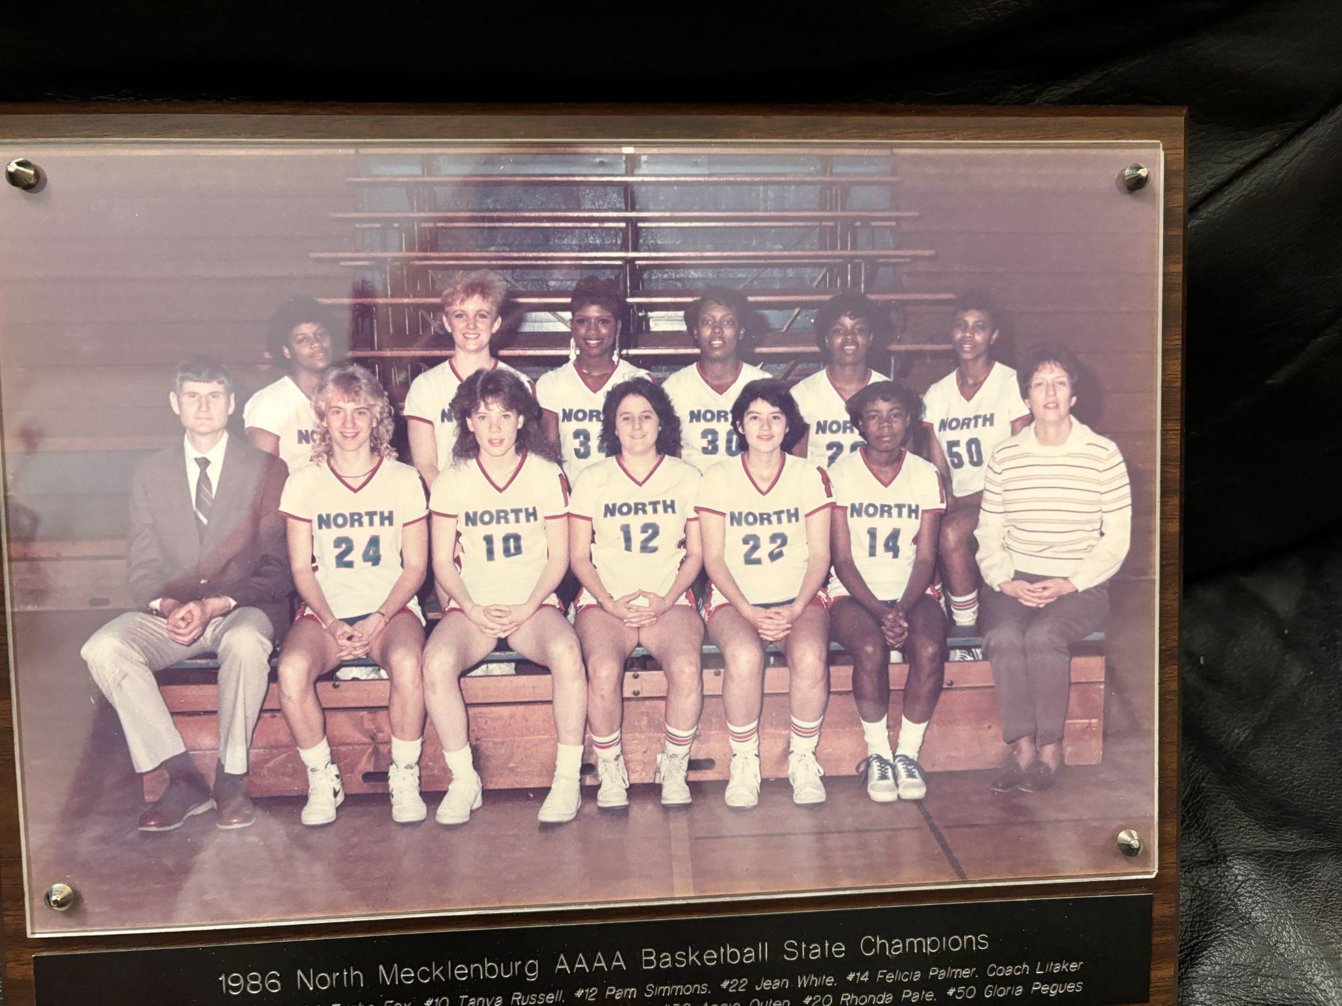
He did everything for the community, his students, players, family, church, neighbors, and friends.
He was Carroll Mizelle. He was Mr. Mizelle. He was Coach Mizelle.
Not only will the state championship plaque house his name forever, but he will also be in the minds of his students, neighbors, families, friends, players, and members of his church.
No more knocking on the door with vegetables from his garden. No more texts saying the train is coming. No more sword fights to slay the dragon. No more basketball games where he will be sitting in the stands.
The hole of his absence will no doubt be felt, but the community can find comfort knowing they knew and loved him.
Carroll changed his town, he changed his school, and he changed his family. He hung up his armor and his sword and was laid to rest as a Viking. The only thought he had in the hours before he passed: “I have no regrets.”

.

